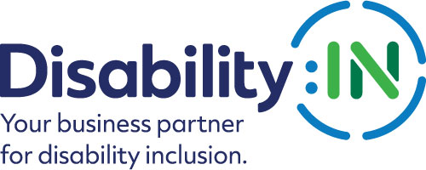

2020 Disability:IN Inclusion Awards
NextGen Leader of the Year
Award Nomination Form

THE DEADLINE FOR NOMINATIONS IS:
FRIDAY, NOVEMBER 22, 2019

The NextGen Leader of the Year Award recognizes an alumnus of the Disability:IN NextGen Leader Initiatives (Talent Accelerator or Mentorship Exchange, formerly Rising Leadership Academy and Rising Leaders Mentorship Program) who has shown outstanding leadership and commitment to disability inclusion within their company.

Award criteria:
- The nominee must be an individual from the corporate sector (not a government entity or nonprofit service provider).
- The nominee must be an alumnus of the Disability:IN Talent Accelerator or Mentorship Exchange (formerly Rising Leadership Academy and Rising Leaders Mentorship Program).
- The nominee must be active in advocating for and advancing disability business inclusion, continuously and current for the past calendar year.
- Self-nominations are accepted, although not encouraged.
- The winner must be prepared to accept the award that will be presented during the 2020 Disability:IN Annual Conference and Expo in Orlando, July 13 – 16, 2020.

Please note that if your nominee is selected to receive this award, you will be asked to submit photos and/or videos to Disability:IN for use in an introductory video that will be shown during the award presentation at the 2020 Disability:IN Annual Conference and Expo in Orlando, July 13 – 16.

*These visuals will need to be submitted 4 weeks after notification. Will you be able to do this? Yes __ No__
Please complete the nomination form in its entirety: (Limit responses to three pages)
Information on Nominee:

Nominee Name
Title
Organization
Mailing Address
Phone
Email

Contact information of person responsible for completing the nomination form if other than nominee:
Name
Title
Organization
Mailing Address
Phone
Email

Contact information of primary company representative to be notified if nominee is a finalist:

Name
Title
Organization
Mailing Address
Phone
Email
Website

Contact information of a secondary company representative to contact if nominee is a finalist:

Name
Title
Organization
Mailing Address
Phone
Cell Phone
Email
Please provide a brief bio (no more than one page) for the committee to review. Supporting documents are encouraged and will not count against word limits.

- How has the nominee been engaged in advancing disability inclusion at their company? Please list specific examples of the role the nominee has played. (1,000 words or less) 40 points

- How has the nombinee shown leadership in advancing disability inclusion and equality both inside and outside of the business (involvement in ERG/BRG, mentorship, accessibility initiative, etc.)? 35 points

- Please describe how Disability:IN’s (formerly USBLN) programs helped get the nominee where they are today. 15 points

- Why is the nominee deserving of this award? (500 words or less) 10 points

Total Points Possible = 100

PLEASE DO NOT CONVERT FORM TO PDF. Submit your electronic nomination to: Jordan@disabilityin.org. General questions about this submission should be directed to Jordan Krug at Jordan@disabilityin.org.

The deadline for nominee submissions is 5 p.m. EST on Friday, November 22, 2019. Award recipients will be selected by committee and will be announced at the 2020 Disability:IN Annual Conference and Expo in Orlando, July 13 – 16. Please note that late nominations will not be accepted.

Thank you for submitting your nomination to the
2020 Disability:IN Inclusion Awards!

