**Disability:IN logo with tagline your business partner for disability inclusion**

**NextGen iLAB Toolkit***Driving innovation through inclusion*

# TABLE OF CONTENTS

Message from Jill Houghton 5

Watch the Video 6

The iLab Task Force 7

Introduction to the iLab 8

The ROI for Holding an iLab 10

The Planning Team & Key Elements  12

Developing the iLab 14

The Event 18

Post Event Considerations  20

Appendix  21

Sample 1-Day Agenda

Sample 3-Day Agenda

Disability Considerations

Sample Supply List

Sample Mentor/Subject Matter Expert Recruiting Announcement

Sample Student Recruiting Announcement

Sample Mentor Instructions

Tips for Mentors

Sample Subject Matter Expert Instructions

Sample Student Instructions

Sample Poster Template

Sample Judging Sheet

Sample Event Survey

Sample Post-Event Thank You for All Volunteers & Sponsors

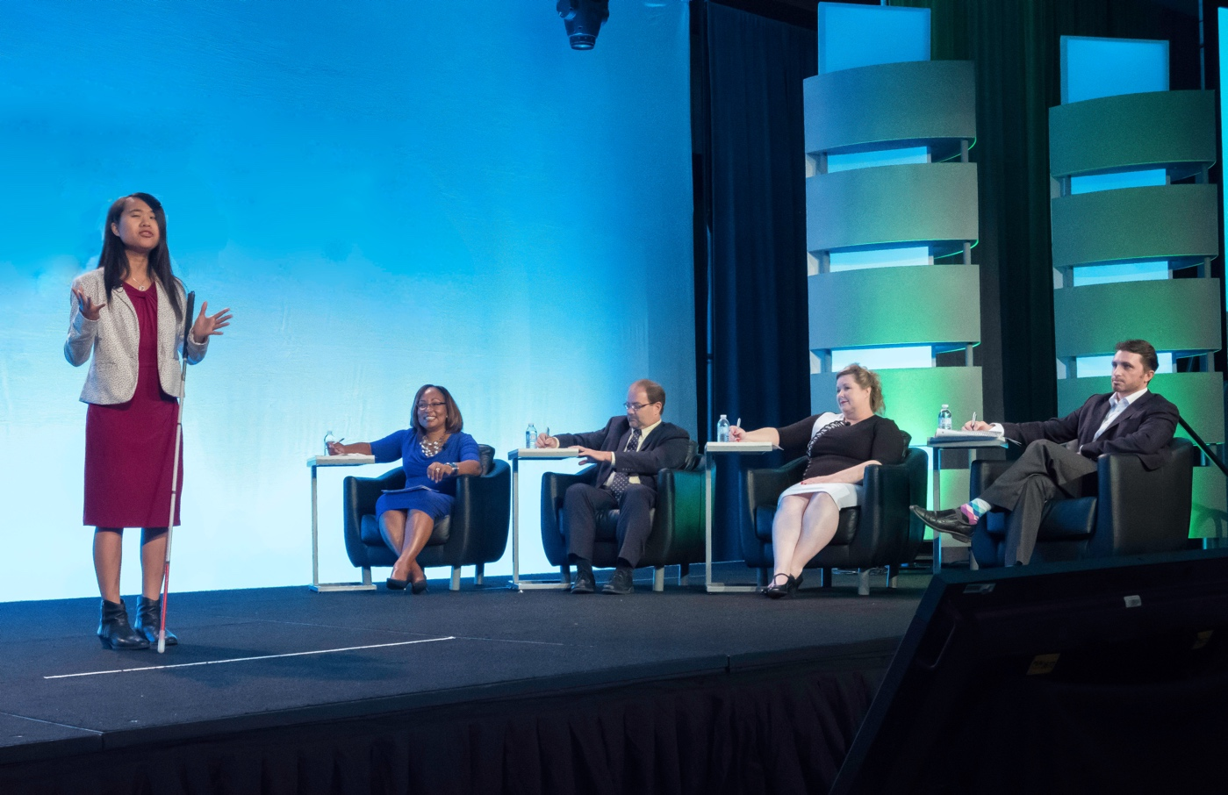

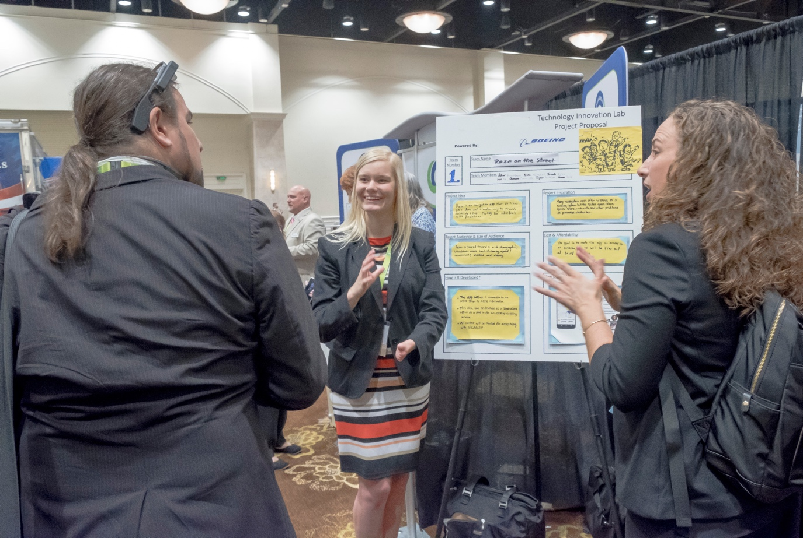

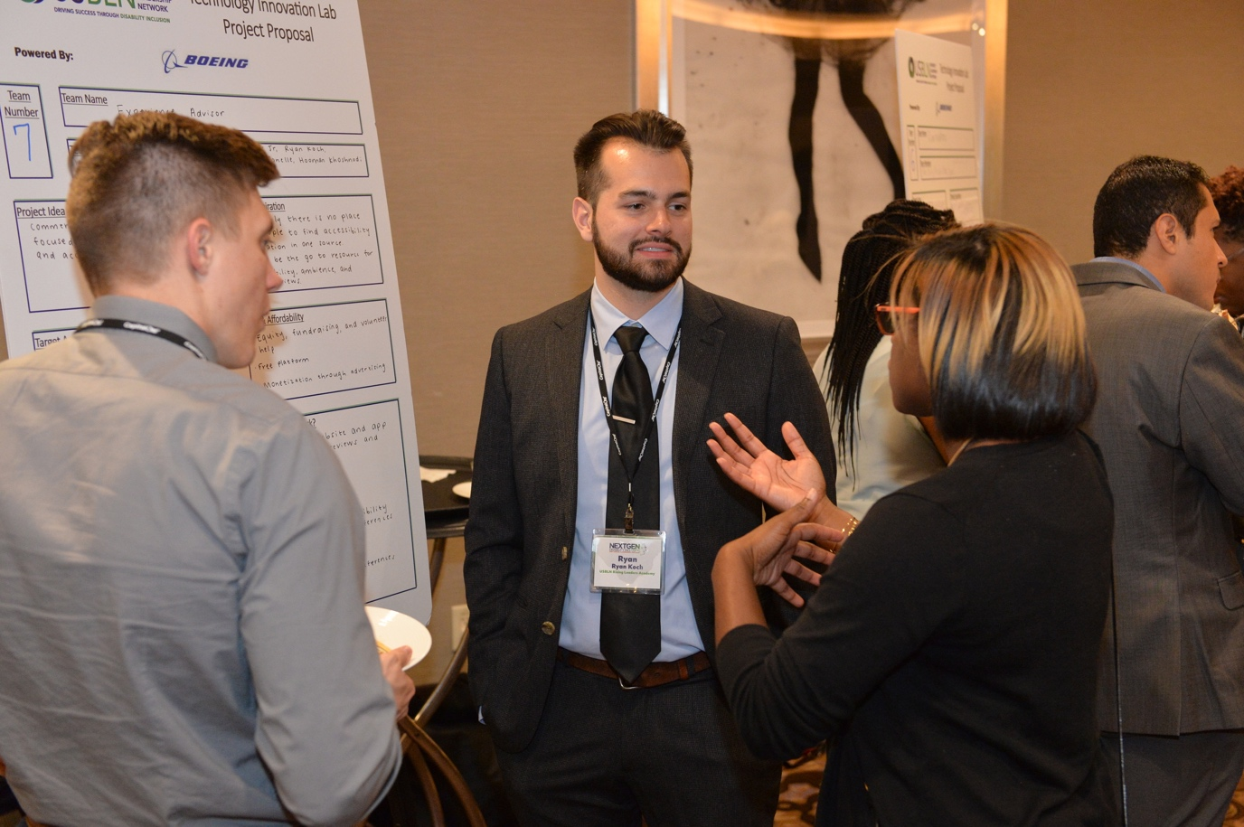

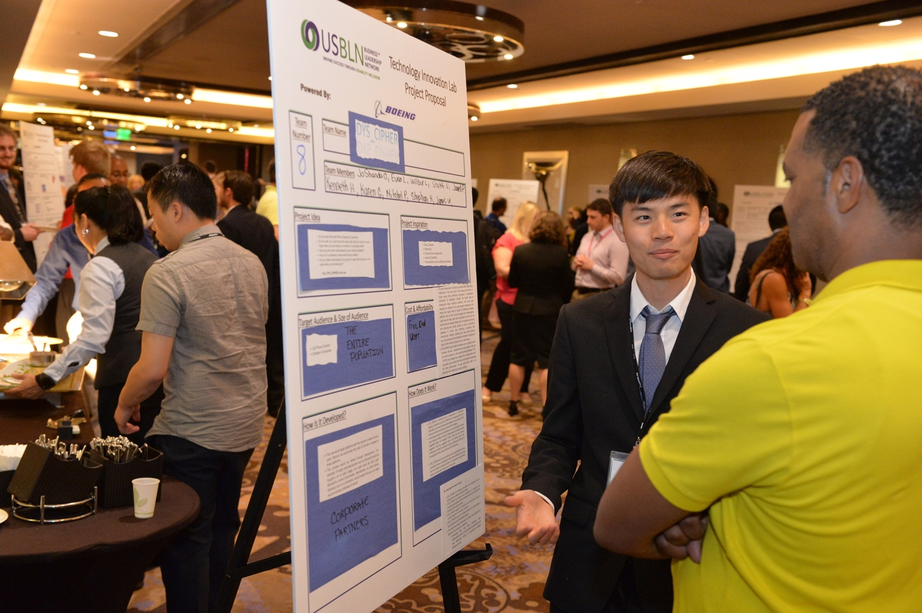

# MESSAGE FROM JILL HOUGHTON

At [Disability:IN](https://disabilityin.org/), we envision a world in which people with disabilities can participate fully and meaningfully. To achieve this, we empower business to be disability inclusive and harness the talent of the estimated 1 billion people with disabilities worldwide.

On behalf of the Disability:IN Board of Directors and staff, I am excited to share the iLab Toolkit that guides corporations, including disability-focused Employee/Business Groups (ERG/BRGs), in unlocking the creativity and innovation from talent with disabilities. The iLab Toolkit, funded by the Mitsubishi Electric America Foundation and The HSC Foundation, allows for replicating the very successful Disability:IN Innovation Lab (iLab) that is held during the Talent Accelerator at the Disability:IN Annual Conference.

By using the iLab Toolkit, we found students gain critical skills and connections for career and life success, and in parallel, business partners who serve as mentors and subject matter experts become advocates for inclusion of students with disabilities in their companies’ internship and hiring programs. While the Disability:IN’s iLab is designed for college students or recent graduates with disabilities, you are welcome to adapt it for younger students or for groups that include students with and without disabilities.

We launched this initiative with Disability:IN Affiliates and our Corporate Partners’ disability-focused Employee/Business Groups (ERG/BRGs) as our primary audience. Big thanks to our planning task force which included representatives from corporate partners who are active in their companies’ ERG/BRGs and Disability:IN Affiliates.

We also invite any organizations promoting full inclusion of students with disabilities in the workplace to use this amazing tool. We look forward to hearing about the innovative solutions and ideas!

Best regards,

Jill Houghton  
*President and CEO*  
Disability:IN

# WATCH THE ILAB VIDEO

Accessible video available on Vimeo through [**this link**](https://vimeo.com/323471589).

# THE ILAB TASK FORCE

* **Elaine Kubik**   
  Disability:IN
* **Emily Malsch**  
  Disability:IN
* **Hannah Chadwick**  
  Disability:IN and NextGen Alumna
* **Jonathan Duvall**  
  NextGen Council
* **Josh Goldschmid**  
  The Boeing Company
* **Keri Gray**  
  Disability:IN
* **Kevin Webb**  
  Mitsubishi Electric America Foundation
* **Maggie Roffee**  
  Disability:IN
* **Ray Parker**  
  NextGen Council
* **Tara Havlicek**  
  Mitsubishi Electric America Foundation
* **Tailor Dortona**  
  NextGen Council
* **Teresa Danso-Danquah**Disability:IN and NextGen Alumna

# INTRODUCTION TO THE INNOVATION LAB (ILAB)

**Purpose & Goal**

You may have heard of “hack-a-thons” where a group comes together to create a software to accomplish a set goal. The Disability:IN Innovation Lab (iLab) is a “hack-a-thon” used to solve any problem that enhances the ways in which we live, shop, and/or have experiences.

Circle graphic with inner rings. From outside, moving inward it is labeled as: Mentors & Subject Matter Experts, students, universal design principles, and challenge in the center.

The Disability:IN iLab brings together college students with disabilities and career professionals, with and without disabilities, under the principles of universal design to dream up the next big ideas in design or technology. The iLab was designed to show that people with disabilities can be the “catalyst for innovation” with design breakthroughs that will benefit the world! While the Disability:IN model presented here is designed for college students or recent graduates with disabilities and volunteers from our Partners, it can easily be adapted for younger students and groups that include students with or without disabilities.

The iLab deepens relationships with local universities, nonprofits, businesses, and governments to collaborate and show that workplaces that include people with disabilities can become better innovators. Volunteer career professionals, with or without disabilities, serve as mentors or subject matter experts. Students, working in teams, leave the iLab with a greater understanding of team work and a new confidence that they can participate in solving world challenges.

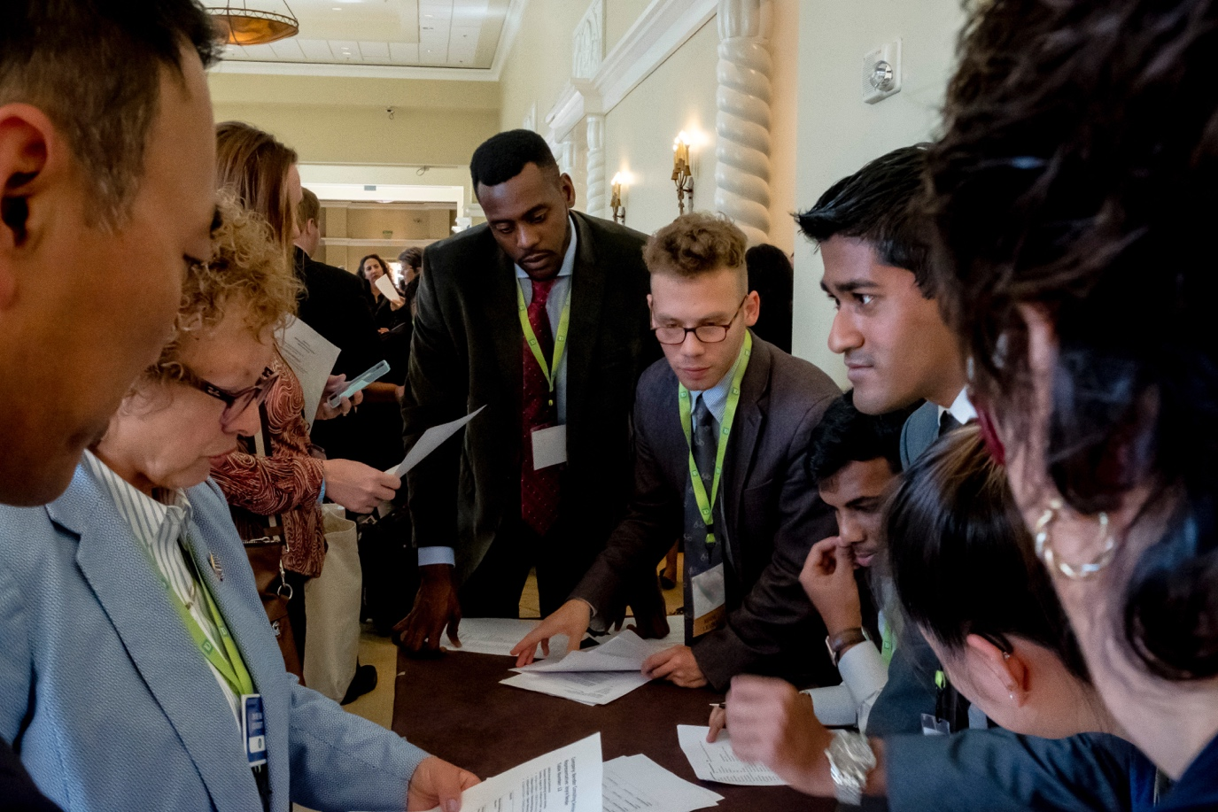

The best result of the iLab is the actual creative process itself. The process taps into what students have studied at their universities. With the guidance of the volunteer business professionals the students discover how to apply business-based critical and design thinking methods.

The volunteer business professionals become champions of employment opportunities for not only these students but also for other job applicants with disabilities.

**QUESTIONS? Email** [**info@disabilityin.org**](mailto:info@disabilityin.org)

# THE ROI FOR HOLDING AN iLAB

**Reasons to involve multiple organizations for planning the event**

* Local universities & colleges, nonprofits, Workforce Development & Vocational Rehabilitation offices assist in recruiting students for the program
* Business partners or business units within your company learn that individuals with disabilities are innovative in solving local or world challenges and will invest resources to support the iLab

**The BEST part of the iLab**

* Witnessing the collaborative effort and the innovative technological ideas of an inclusive society that comes from the Next Generation of employees. The excitement is contagious, and it will no doubt have an impact on all who participate.

**The benefits of the iLab for the Students**

* Students learn valuable skills in problem solving and teamwork outside of the classroom focusing on real world problems
* Students have a venue to show their skills and talents
* In an intentionally planned group that includes diversity in disability, ethnicity and economic backgrounds, students will gain an appreciation of individuals with other disabilities and backgrounds as well as disability pride
* Students learn what disability-related accommodations other individuals need to do their best work

**The benefits of the iLab for the Sponsoring Organization and Business Partners**

* Meeting some of the brightest talent that they may be able to bring to their organization
* Solving a challenge needed for their company or for the world
* Gaining a greater understanding of what is needed to successfully transition talented next generation employees from school to the workplace
* Understanding what disability-related accommodations the members of the next generation workforce use to be productive
* Great Press

|  |  |
| --- | --- |
| Headshot for Kevin Webb | “The Disability:IN Innovation Lab provides an opportunity for students with disabilities to gain experience working on a project team on real world problems, as well as demonstrate their talents and problem-solving skills to professional mentors and subject matter experts. Participating employers can observe the students’ capabilities, identify budding talent to hire for their companies, and potentially create an innovative product or service to bring to market.”  - Kevin R. Webb   *Sr. Director, MITSUBISHI ELECTRIC   AMERICA FOUNDATION* |
| **Headshot for Hannah Chadwick** | “The Innovation Lab is an opportunity for people with diverse backgrounds to collaborate on an idea that will change the world. This project can enhance leadership skills, and reinforce the importance of team-work. In working on the same team, members will have a better understanding of inclusion, and in turn create a more diversified work environment.”  - Hannah C   *NextGen 17* |

# THE PLANNING TEAM & KEY ELEMENTS

The iLab, like much in life, is only as good as the work that is put into it. That includes the planning. This area will **need to be customized** for your size, budget, location, venue, and challenge. Allow 6 - 12 months for planning prior to launching the event.

**The planning team should include:**

* Individuals with a range of skill sets; a good number is 5 to 10 individuals
* Incorporate the expertise that is needed to make YOUR iLab a success

**Key elements are:**

* Organizational support
* Higher education connections (e.g. Career Services, Disability Services, Alumni Associations)
* A venue, a challenge, participants, mentors and subject matter experts

**The planning committee or its task forces will need to address some if not all the following:**

* Project Management
* Program Planning
* Fundraising
* Communications & Marketing
* Budgeting

**Project Management**

* Decide who on the Planning Committee will take primary responsibility for overall management of the event
* It would be an advantage if the person selected has a strong background in managing events or teams

**Program Planning**

* Select individuals who are experienced in planning educational internal or community programs
* Include at least one or two individuals who have a strong cross-disability background
* [Accessibility](http://www.adahospitality.org/accessible-meetings-events-conferences-guide/book) and [Accommodations](https://askjan.org/products/Accessible-Meeting-Event-Checklist.cfm?cssearch=2000334_1) need to be addressed at the start of the planning process
* This is an opportunity to form a task force and involve individuals who are not on the Planning Committee; but at least one Planning Committee member should be on it for continuity
* This area will require most of the work so consider having a task force of 10 – 15 individuals

**Fundraising**

* If your organization does not have funds available to host an iLab, fundraising will need to be done prior to confirming the event
* This is a skill set that at least one member of the planning committee should possess
* The individual chosen to lead this may want to recruit planning committee members as well as others in the organization for specific assignments

**Communications & Marketing**

* There should be at least one member of the Planning Committee that has a communications or marketing background
* They may want to form a small task force to generate creative ideas and assist with implementation
* Either the primary Communications/Marketing lead or one or two of the task force members should understand accepted [disability language](http://www.askearn.org/topics/retention-advancement/disability-etiquette/) and [accessible communications](https://www.ada.gov/effective-comm.htm)

**Budgeting**

* Your planning committee needs at least one member who has great budgeting experience or skills
* This area probably does not need a task force but can be done by one or two planning committee members
* In-Kind donations will stretch your budget and provide an opportunity for supporters to increase their engagement

|  |
| --- |
| **RESOURCES TO CONSIDER** |
| **Facility Rental/Food/AV Equipment** |
| **Staff/Consultant Fees/Advertising** |
| **Disability Related Accommodations** (Sign Language interpreters, CART, Personal Assistance, Braille, Large Print, Transportation) |
| **Poster Boards/Markers/Printing & Graphics/Award Plaques** |

# DEVELOPING THE ILAB

**There are many details that need to be handled throughout the planning process. The following should be decided early.**

**1. The length of the iLab**

How much time will the participants have to formulate the ideas? Disability:IN has found that working virtually with the groups on their ideas prior to the event enables the on-site event to run more smoothly especially if you are planning an event that will be held on one day from 2 to 8 hours. If you are planning a weekend event, then less pre-event virtual meeting time will be needed.

**2. The Challenge Model**

Determining the challenge is a vital step to having a successful iLab

* Do you want the challenge to be very specific like those presented at “hack-a-thons”?
* Is there a specific challenge that your organization, your community, or the world has that you would like the participants to tackle?
* Do you want the challenge to be very broad? If so, you can ask the participants to come up with the next technology that will change the world (i.e. Uber, Facebook, Amazon, etc.).
* Since your iLab will have multiple teams, will all teams have the same challenge? Will they choose from a few you provide? Will they come up with their own?
* Ideas from past Disability:IN iLabs are:
* Develop technology that will assist with the employability of people with disabilities
* Create the next “disruptive” technology such as Facebook, Amazon, Uber, etc.
* Disability: A Catalyst for Innovation

**3. Choosing the depth of your challenge**

The length of your event and the skills of your students, mentors and subject matters experts will determine how you develop the challenge. For example, you may ask the students and mentors to come up with rough ideas without many details solidified or you may want a fully developed business plan.

* How do you want the groups’ outcomes of the iLab to be presented?
* Do you want the participants to write a report, make a poster, pitch their ideas to judges, etc.

Thinking about these details can influence a lot of the other details of the iLab.

**4. Choosing a location for the in-person event**

This will also depend on the size and length of the iLab. It could be a small conference room or a convention center. Also keep in mind the activities that you want the participants to do during the event. Will they need audio/visual equipment, a stage to present, room for posters to be lined up, etc. Make sure that your location can accommodate all that you want your iLab to be. And make sure that the location is accessible, including parking and rest rooms. (See Disability Considerations)

**5. Create a Budget**

Within the budget, you should factor in costs such as venue, AV needs, disability-related accommodations, staff/consultant fees and supplies.

* Make sure you have the supplies needed to make your iLab successful. This includes both the ideation portion and the presentation of solutions. Typically having supplies like post-it notes, pens, markers, construction paper, scissors, glue, etc. are good for ideation of innovations. (See Supply List)
* Depending on how you want the final products to be presented, you may also want to supply formatted poster boards. (See Sample Poster Template)
* Supplies for constructing a prototype, if that is your end goal, may also be necessary. This really depends on how in depth you want their solutions to be.

**6. Recruiting Mentors**

This highly depends on the size of your iLab and how in-depth you want the solutions to be. For large iLabs of several teams, you may wish to have a team liaison for each team. (See Sample Announcement) / (See Sample Mentor/Subject Matter Expert Sample Announcement)

For the first year, ideally these will be members of your planning teams who understand the purpose, goals and flow of the iLab. For subsequent years, consider recruiting alumni of the iLab. They will help monitor the team’s progress and direction as well as keep the group on schedule. They will also help keep their assigned group organized and address any team conflicts. It will be important that the mentors understand that they will not ‘run’ the group or take over but will serve as a guide for the students.

**7. Recruiting Subject Matter Experts**

**Where to Recruit:**

* Employers with whom you work
* Members of Employee Resource Groups
* People in other business units within your company

**Who to Recruit**

* Individuals knowledgeable about innovative design
* Professionals with engineering, business, marketing, communications, and budgeting expertise

**What are their Duties**

* Guide the participants and provide answers based on their workplace experience
* Assist on pinpointing the audience, clarifying the idea, refining the process and developing promotion plans
* Serve as floaters and easily identified so the mentors or teams can call upon them as needed

**8. Recruiting Participants**

**Where to Recruit:**

* If you follow Disability:IN’s model in this toolkit, college students and recent graduates with disabilities
* If you adapt it, younger students, youth you currently serve, students with and without disabilities
* A wide range of skills and academic majors
* Diversity of backgrounds including ethnicities, disabilities, race, and sexual orientations

Diversity of thinking and backgrounds can lead to some of the best ideas and result in appreciation of other disabilities, cultures and ideas. (See Sample Announcement)  
  
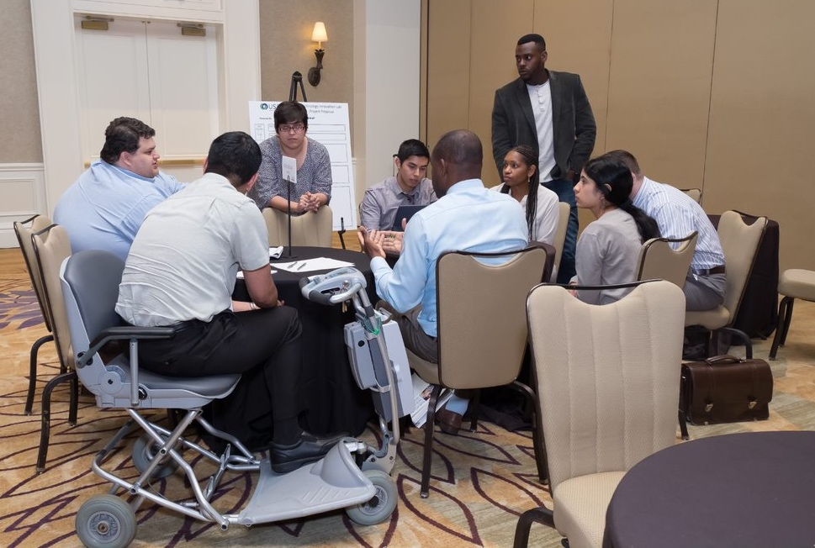

**9. Pre-Event Considerations**

**What to do after recruitment is finalized**

* Assign students and mentors to teams
* Set up orientation call with the mentors
* Briefing on goals
* Reviewing Disability etiquette
* Discussing their role
* Providing their team assignment
* See sample mentor instructional list (See Sample Instructions)
* Set up orientation call with the subject matter experts
* Briefing on goals
* Reviewing Disability etiquette
* Discussing their role
* See sample subject matter experts instructional list (See Sample Instructions)
* Set up orientation call with the students
* Briefing on goals
* Reviewing Disability etiquette
* Discussing their role
* See sample student instructional list (See Sample Instructions)
* Set up planning calls for the student teams
* ‘Getting to know you’ (e.g. name, location, school, major, skills, disability)
* Brainstorming on products to meet the ‘challenge’
* Narrowing down potential products to 2 or 3 or deciding on 1
* Include the mentors assigned to the teams
* Create a Hashtag for the event

# THE EVENT

The event is showtime for the iLab. Depending on the length and depth of what your planning team decides is feasible, it can incorporate a lot of speakers and sessions or be simple.

The schedule should be very detailed while also leaving flexibility for last minute changes or unexpected occurrences. Most iLabs will include an opening speaker and an overview of the purpose and process. They also include time for the participants to work on their ideas, a pitching component to ‘sell’ their projects and a judging session with prizes.

1. **Opening the Session**: Since the iLab will have sponsors or a funding organization, invite them to open the session with brief and motivational remarks. This is also the venue for someone from the planning committee to review the ‘rules,’ present the flow of the session, and thank all those who contributed time or financial support. If you have time, you can plan ice-breakers so the students get to know who is in the room or in their group.
2. **Team Session**: This is typically the main part of the iLab where the teams will get together and work on their projects. Each participant should have received their team assignment prior to the event and may have met virtually to brain storm or just to get to know each other. Generally, teams of 5-10 participants have the most success because there is diversity of thoughts and life experiences and everyone feels involved. The teams should be given ample room, time, and supplies to accomplish the goals you have set out for the project. This is also a good time for the teams to meet the subject matter experts that you have chosen to help them on the details of their ideas. Make sure to reiterate what the outcome of the project should be whether it is a poster, prototype, business plan, report, etc.
3. **Pitching and/or Judging**: If you have the time and enough attendees, plan both a pitch opportunity with a voting component and a voting session for all the teams to demonstrate the solution that they developed. This could be a **poster session**, presentations, demos of the prototypes, or a combination of these. The two or three highest vote recipients then present their projects to a panel of judges. These exercises provide the students with invaluable learning experiences and engage business and community partners. Either way, be sure to clearly articulate the **judging criteria** to the participants, the audience and the judges.
4. **Awards**: In most cases, it is good to give the participants something to work for. Awards can be prizes donated by the sponsors, funding to continue developing their ideas after the event, publicity in a local media outlet, etc. Be sure to plan what the awards will be ahead of time and leave time to present the awards to the winning teams.

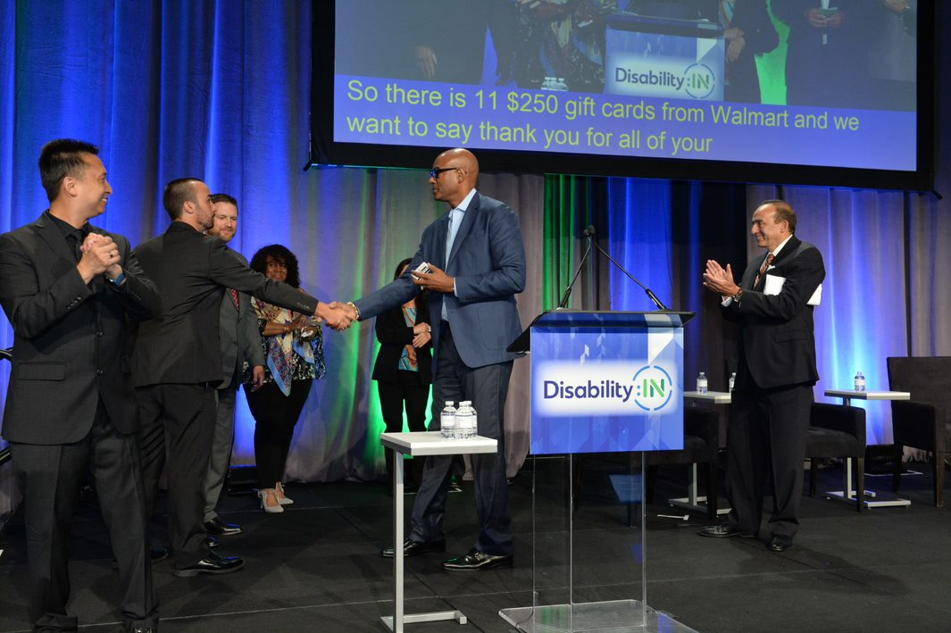

1. **Social Media**: Post visuals of the event’s hashtag and provide frequent reminders to the attendees to Tweet, Facebook, etc. throughout the event.

Icons shown: hashtag, twitter, facebook

# POST-EVENT CONSIDERATIONS

The iLab doesn’t need to end after the awards are given out. Sponsors typically expect to learn the outcomes after the event.

**Recommended Post-Event Actions**

* Develop surveys to send to the students, mentors and subject matter experts
* Ask for successes
* Ask for areas for improvement
* Use the results to plan next year’s event
* See Sample Event Survey
* Consider bringing the winning team’s or any of the teams’ ideas to market
* Your sponsors may want to help with this
* Invite local companies or venture capitalists to the event
* Encourage the students to further develop their solutions – perhaps a student will start their own company!
* Plan how to best incorporate long-term relationships with the students and the business and community participants
* Send Thank-You letters
* Are internships or jobs a possibility for the students?
* Would the subject matter experts and mentors be interested in mentoring the students post event?
* What students may be ready to come back to future iLabs as mentors or subject matter experts?
* Will the mentors and subject matter experts return with colleagues who will participate next year

# APPENDIX

## SAMPLE 1-DAY AGENDA

**Prior to the Event**

* **One month prior**: Recruitment finalized for all participants including students, subject matter experts and mentors
* **One month prior**: Mentors and students assigned to their teams
* **2-3 weeks prior**: Mentors schedule a call with their teams for introductions and idea brainstorming

**Event Day**

* **9:30pm-12:30pm**:   
  **iLab design teams work with their mentors to develop ideas for a new technology.** Teams will be provided with a poster template they will complete by 1 pm
* **9:30am-9:35am**:   
  Introductions of iLab team members and Sponsor representative(s)
* **9:35am-9:40am**:   
  Sponsor(s) gives a welcome and talks about their company
* **9:40am-9:50am**:   
  Subject Matter Experts are introduced
* **9:50am-12:00pm**:   
  Teams in Explore Phase – Teams will solidify their ideas in their groups in the main room and smaller rooms as available
* **12:00pm-12:25pm**:   
  Working Lunch with Rapid Report Back – Teams will gather in the main room, pick up a boxed lunch or select from a cold buffet of non-messy & easy to eat options, share their refined problem statements and ideas with the entire group. One member from each team will have 1-2 minutes to present their idea
* **12:25pm-12:30pm**:   
  Closing & Recap
* **12:30pm-1:00pm**:   
  Teams will finish their posters and setup for pitching their ideas
* **1:00pm-4:00pm**:   
  Event attendees have an opportunity to learn about the designs & vote for their favorite; Student teams are encouraged to take turns staffing their booth to explain their designs
* **5:00pm**: **Working Dinner**  
  while iLab Leads tally the results, participants select from a buffet of non-messy & easy to eat options. Top 2 teams are announced.
* **6:00pm**: **Shark Tank Pitches to judges**
* Top two iLab design teams have 7 minutes each to present their ideas
* Following each presentation, the judging panel has 3 minutes for Q&A “Shark Tank” style
* Judges confer, reach consensus and the awards are announced
* Group photo opportunity

**Post-Event Possible Opportunities**

* Design Teams are encouraged to refine their ideas with opportunities for continued assistance
* Participants are encouraged to integrate these ideas into their workplaces
* Sponsors may work with teams to identify ways to move their projects forward

## SAMPLE 3-DAY AGENDA

**Prior to the Event**

* **One month prior**: Recruitment finalized for all students, subject matter experts and mentors
* **One month prior**: Mentors and students assigned to their teams
* **2-3 weeks prior**: Mentors schedule a call with their teams for introductions and idea brainstorming

**Day 1**

* **1:30pm-4:30 pm**:   
  **iLab design teams work with their mentors to develop a new technology idea.** Teams will be provided with a poster template they will complete by noon on Day 2
* **1:30pm-1:35pm**:  
  Introductions of ilab team members and Sponsor representative(s)
* **1:35pm-1:40pm**:   
  Sponsor(s) gives a welcome and talks about their company
* **1:40pm-1:50pm**:   
  Subject Matter Experts are introduced
* **1:50pm-4:00pm**:   
  Teams in Explore Phase – Teams solidify their ideas in their groups in the main room and smaller rooms as available
* **4:00pm-4:25pm**:   
  Rapid Report Back – Teams gather in the main room to share their refined problem statements and ideas with the entire group. One member from each team will have 1-2 minutes to present their idea
* **4:25pm-4:30pm**:  
   Closing & Recap
* **Evening**:   
  Dinner & Design Teams working on their own to develop their designs

**Day 2**

* Design Teams continue to work on their own to refine and finalize their design
* **By Noon**:  
  Designs completed.
* **12:00pm-4:00pm**:   
  Student teams set up posters in an exhibit area & practice their pitch
* **5:00 pm**:  
  Dinner & Networking
* **6:00pm-8:00pm**:  
  Invited community folks visit each team to learn about the designs & vote for their favorite. Student teams are encouraged to take turns staffing their exhibit to explain their designs

**Day 3**

* **9:00am-10:00am**:  
  Breakfast and Networking
* **10:00am**:  
  iLab Leads tally the results. Mentors and top 2 teams informed
* **10:00am-11:15am**:  
  iLab Leads meet with the Top 2 vote-getting design teams to prepare for their presentations
* **11:30 am**:  
  Shark Tank Pitches
* The top two iLab design teams have 7 minutes each to present their ideas.
* The panel has 3 minutes with each team for a Q&A “Shark Tank” style
* Judges confer, reach consensus and the winner is announced

**Post-Event Possible Opportunities**

* Design Teams are encouraged to refine their ideas with opportunities for continued assistance
* Participants are encouraged to integrate these ideas into their workplaces
* Sponsors may work with teams to identify ways to move their projects forward

## DISABILITY CONSIDERATIONS

Note: For detailed information see The Mid-Atlantic ADA Center’s Online Accessible Meetings, Events and Conference Guide at <http://www.adahospitality.org/accessible-meetings-events-conferences-guide/book>

**Pre-Event**

* Include a line in your budget for accommodations
* Include request for accommodations and dietary restrictions in the registration form
* Check that announcements and registration materials are accessible to all

**Location Selection**

* Accessible parking spaces including van accessible spaces
* A level pathway with no steps or curbs leading from the parking and from the drop off area to the main entrance you will use
* Entrance doors with no steps, 32 inches clear width and a light weight door (less than 5 pounds pull force) or an automatic door opener
* Tables with a surface height of no more than 34 inches and no less than 28 inches above the floor with at least 27 inches of knee clearance
* Seating movable and flexible
* Elevators if there are meeting or event rooms on multiple levels
* Room signage that has raised or Braille characters
* Good lighting; be aware of flashing lights or contrasting light and dark patterns
* Audio/Visual equipment available for microphones, remote captioning, videos etc.
* Accessible rest rooms on the same level as the meeting rooms
* Ramps available if using a stage or a speaker platform

**Other**

* Accessible guest rooms
* Sign Language Interpreter & Captioning services
* Materials available in alternate formats
* Ensuring the event is fragrance free
* Food should not include products that can cause cross-contamination such as nuts & peanuts
* Accessible transportation
* Emergency planning

## SAMPLE SUPPLY LIST

**Based on 10 teams with 5 Students per Team:**

* 10x5 Pens (for ideation)
* 10x5 Sets of Sticky Notes (for ideation)
* Various colors of construction paper
* 10x5 Set of Sharpies (Ultrafine)
* 10 Sharpies (Fine)
* 10 Printed poster board for project pitches (1 for each group)
* 10 Easels for displaying the posters at the
* 10 Scissors (cutting construction paper)
* 20 Glue sticks (for mounting construction paper)
* 10 Rulers (for lining things up on the posters)
* 10 Whiteout (we made mistakes on our poster)
* 500 Voting Ballots (pieces of paper to mark Team 1 to Team 10) (125 copies of document)
* 1 Voting Box

## SAMPLE RECRUITING ANNOUNCEMENT FOR MENTOR / SUBJECT MATTER EXPERTS

Great Volunteer Opportunity for Business Professionals in Support of Students with Disabilities

(Organization X) is Recruiting Mentors for our 2020 Innovation Lab (iLab) which will take place on (Insert Date) at (Insert Place).

The iLab is a “hack-a-thon” used to solve any problem that enhances the ways in which we live, shop, and/or have experiences. The experience will provide college students with disabilities the opportunity to work with business professionals on small teams to create the next disruptive technology a’ la Facebook and Uber.

The Mentor will receive orientation and training virtually with the iLab planning team approximately 4 weeks before the live event. The mentor will also meet virtually with their assigned team of 5 – 10 students approximately 2 weeks prior to the iLab to brainstorm potential project ideas. During the event, the mentor will guide and encourage the students to work as a team and express their creativity and imagination.

Subject Matter experts are needed during the event to answer technical questions on such subjects as product development, technology, testing, and marketing.

Students leave the iLab with a greater understanding of team work and a new confidence that they can participate in solving world challenges. As a volunteer business professional you have the opportunity to be a champion for career development for the next generation of employees with disabilities.

To volunteer or for more information contact (add your contact information)

## SAMPLE STUDENT RECRUITING ANNOUNCEMENT

A Career Building Opportunity Exclusive for College Students with Disabilities

(Organization X) announces its 2020 Innovation Lab (iLab) for college students with disabilities which will take place on (Insert Date) at (Insert Place).

During this 1-day event you will design a great new product working on a team of students guided by mentors and subject matter experts from business.

The winning teams win prizes. All team members gain critical workplace skills and business connections.

To apply or for more information contact (add your contact information)

## SAMPLE MENTOR INSTRUCTIONS

Thank you for serving as an Innovation Lab (iLab) Mentor. The iLab will be held (insert place, date and time). The event brings together (x Number) college students with disabilities.

**What**

The iLab program aims to demonstrate that individuals with disabilities can be a catalyst for innovation and that our students can be valuable innovators for companies. (Organization X) has assembled a diverse group of students for this exciting event along with mentors and subject matter experts who will play an important role.

The theme for this year’s event is “disability: a catalyst for innovation” so we are asking the participants of the iLab to come up with an idea that supports this theme. The participants will leave the iLab with a new confidence that they can be drivers of innovation and they have the ability to make a huge impact in their careers and companies. The best result of the iLab is not always the ideas that are created, but the actual creative process itself which taps into what many students are learning in school through critical and design thinking methods.

**What kind of ideas count?**

Ideas for the projects are wide open. Teams can choose to solve any challenge they wish in a variety of ways using their creativity. Some teams may want to make air travel more convenient or tackle grocery shopping issues. Other teams may choose to design a technology solution for the hiring process or come up with a new personal transportation idea. The sky’s the limit! The choice will be up to each team. While some teams may choose to create an actual prototype out of paper and office supplies, the goal for each team is to prepare their design on a poster board for presentation.

**Where and When**

There are four phases of the iLab.

* **Phase 1**: Pre-Conference Work takes place before the iLab.
* **Phase 2**: The In-person Event
* **Phase 3**: Project Design Exhibits & Voting
* **Phase 4**: Presentations by Top 2 Vote-Getting Teams

**Mentor Role** **and Responsibilities**

* Your role is to help the teams get started right away.
* You will facilitate the team rather than lead it. You are not the team’s leader. You can help the group choose a team leader if they wish to designate one.
* Keep the team on track to deliver outcomes. Keep an eye on the time available and what needs to be done.

Keep people on task and energized.

Answer any questions about the event or direct people to the event organizers.

Make sure that everyone is working safely.

Have fun!

## Tips for Mentors

* Familiarize yourself with event timings, activities and team members' names.
* Be proactive in finding team members and introducing yourself.
* Be open and friendly.
* Address people by name.
* Help establish respect and tone for teamwork.
* Offer assistance as and when needed.
* Help your team to make decisions such as who will take notes, delegation, etc.
* Make sure people understand each activity and what is being asked of them.
* Allow time for refreshment/comfort breaks as and when needed.
* Encourage everyone to actively listen, including yourself.
* Make sure everyone has the opportunity to speak and is heard.
* Generate discussion and ideas by allowing others to talk.
* Make it clear that there are no wrong or right answers.
* Think of different ways to help foster teamwork.
* Support your team to reach goals together.
* Ask questions to encourage participation.
* Keep the discussion/activity moving.
* Ask open ended questions.
* Keep participation balanced.
* Get agreement on group actions.
* Work toward consensus wherever possible.
* Be positive, enthusiastic, and focused.
* And most importantly, have fun!

**Getting Started with Your Team**

1. **You will be provided with your team of 8-10 students/recent graduates a month before the event.**
2. **Contact your group and schedule at least one conference call at least 2 weeks before the event.** NOTE: It is highly recommended that your teams plan as much as they can before the event. If you don’t have a conference call line, set up your own free conference line at <https://www.freeconferencecall.com/>. Submit your name and email address to receive your conference line information via email.
3. **During your meeting(s) with your group**:
   1. Explain your role as a mentor; working together and helping to guide your team through the iLab.
   2. Have the team members introduce themselves and share information about themselves if they’re comfortable.
   3. Have team members share their employment experiences.
   4. Review the schedule and phases of the iLab.
   5. Ask team members to individually come up with ideas for the team project and then vote and/or brainstorm to come up with the final idea(s). Ask leading questions like: What did you have an issue with this week. What annoys you to have to do, etc. Make sure their ideas start to include the following information:
      1. What is it?
      2. Who does it target?
      3. How does it work or how is it implemented?

**Contact:**

*Add your contact information

## SAMPLE SUBJECT MATTER EXPERTS INSTRUCTIONS

Thank you for serving as an Innovation Lab (iLab) Subject Matter Expert. The iLab will be held (insert place, date and time). The event brings together (x Number) college students with disabilities.

**What**

The iLab program aims to demonstrate that individuals with disabilities can be a catalyst for innovation and that our students can be valuable innovators for companies. (Organization X) has assembled a diverse group of students for this exciting event along with mentors and subject matter experts, who will play an important role.

The theme for this year’s event is “disability: a catalyst for innovation” so we are asking the participants of the iLab to come up with an idea that supports this theme. The participants will leave the iLab with a new confidence that they can be drivers of innovation and they have the ability to make a huge impact in their careers and companies. The best result of the iLab is not always the ideas that are created, but the actual creative process itself, which taps into what many students are learning in school through critical and design thinking methods.

**What kind of ideas count?**

This year the ideas for the projects are wide open. Teams can choose to solve any challenge they wish in a variety of ways using their creativity. Some teams may want to make air travel more convenient or tackle grocery shopping issues. Other teams may choose to design a technology solution for the hiring process or come up with a new personal transportation idea. The sky’s the limit! The choice will be up to each team. While some teams may choose to create an actual prototype out of paper and office supplies, the goal for each team is to prepare their design on a poster board for presentation.

**Where and When**

There are four phases of the iLab.

* **Phase 1**: Pre-Conference Work takes place before the conference starts.
* **Phase 2**: The In-person Event
* **Phase 3**: Project Design Exhibits & Voting
* **Phase 4**: Presentations by Top 2 Vote-Getting Teams

## SUBJECT MATTER EXPERT DUTIES AND RESPONSIBILITIES

1. **The Subject Matter Experts are only asked to participate in Phase 2 of the process.** We ask the subject matter experts to float from team to team and to be available if a team wants some advice about an issue that is within the experience and expertise of the expert.
2. **During the iLab Event**:

* Visit with the teams and provide feedback on their design or approach
* Ask questions of the teams, making sure they have thought about particular aspects of the idea
* Answer questions from the teams, making sure they have access to your expertise
* Provide your unique perspective to the teams.

**Contact:**

*Add your contact information

## SAMPLE STUDENT INSTRUCTIONS

Welcome to the (Oranization X) Innovation Lab (iLab)!

The (Organization X) Innovation Lab (iLab) is your opportunity to collaborate with other students and recent graduates under the common theme “Disability is a Catalyst for Innovation.” The iLab aims to demonstrate that people with disabilities are a catalyst for innovation and that students and recent graduates are valuable innovators for our partner companies to hire. No matter what your background is, you have something incredibly valuable to offer: your daily life experiences as a consumer. These experiences will be used to help understand and look at problems from a different point of view that may create solutions that are entirely different than already-existing ones.

**What kind of ideas count?**

According to TechCrunch, “Uber, the world’s largest taxi company, owns no vehicles. Facebook, the world’s most popular media owner, creates no content. Alibaba, the most valuable retailer, has no inventory. And Airbnb, the world’s largest accommodation provider, owns no real estate. These innovative companies have changed the way we live.” Your team will create an idea for a new or enhanced interface software/technological platform that enhances the ways in which we, including people with disabilities, live, shop, and/or have experiences. How can your team address widely spread everyday problems through technology?

Think big. You and your teammates can choose to solve a world challenge in a variety of ways using your creativity. You can also think of a disruptive idea for an industry like Facebook, eBay, or the smartphone. The sky’s the limit! While some teams may choose to create an actual prototype out of paper and office supplies, the goal for each team is to prepare their design on a poster board for presentation.

Remember, the value is in the interface/platform, not necessarily the product. Seamless makes greasy food joints seem appealing. For many years, iTunes made incredible profits by being the software between the hard work making tunes and the money selling them.

Don’t forget: The key to a great idea that has broad impact is using principles of universal design and human-centered design. Make sure that your idea can be utilized by as many people as possible.

**Where and When**

Prior to the conference, you will work with others on a team to discuss your backgrounds and brainstorm ideas for the project. There are four phases of the iLab.

* **Phase 1: Pre-Conference work takes place before the iLab.** Begin by exposing yourself to some of the innovations created by people with disabilities. For example: Pokémon. Once in your teams, you will start to work with your team virtually through the support of a team mentor.
* **Phase 2: The In-person event.** There will be a brief introduction by the Planning team before teams begin working on their idea. The event organizing team, your team mentor, and a group of business subject matter experts will be available to you to help your team bring your idea to life.
* **Phase 3: Project Design Exhibits & Voting.**
* **Phase 4: The top two teams to collect the most votes will each have 7 minutes to present their final pitch for a chance to win amazing prizes and the award for best design proposal.** You will be given a rubric that outlines each of the different criteria the judges will be looking for.

## SAMPLE POSTER TEMPLATE

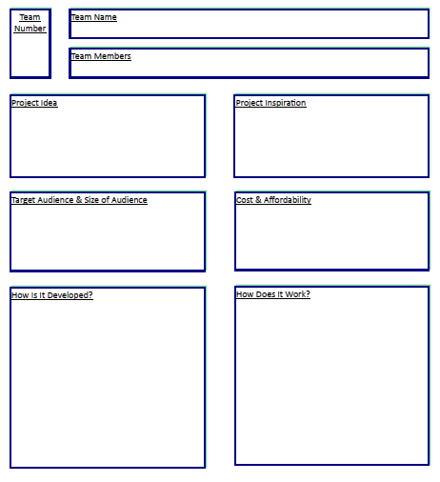

## SAMPLE JUDGING SHEET

Innovation Lab (iLab) Scores

**TEAM**

These areas should be addressed and considered. Scoring can be from 1-10 and discussed among judges.

|  |  |  |
| --- | --- | --- |
| **CRITERIA** | **NOTES** | **SCORE** |
| **Communication:** The project idea is easy to understand and well communicated |  |  |
| **Description:** How the project works is well communicated |  |  |
| **Actual Need:** The project represents a real need |  |  |
| **Audience/Users:** The target audience is clearly defined and incorporates universal design |  |  |
| **Cost/Price:** The cost/affordability was adequately addressed |  |  |
| **Deployable:** The path to development is clearly defined |  |  |
| **Originality:** The project or idea is original |  |  |
| **TOTAL** (out of 70) |  |  |

## SAMPLE EVENT EVALUATION SURVEY

iLab

(Insert Date)

**_______________________________________________________________________**

**YOUR NAME** (optional): ___________________________________________________

**ARE YOU** a: ____Student; ____Mentor; ____Subject Matter Expert; ____Volunteer

**_______________________________________________________________________**

Excellent Poor

1. **The iLab Teams were**: 5 4 3 2 1

2**. The iLab materials were**: 5 4 3 2 1

3. **Overall the iLab was**: 5 4 3 2 1  
____________________________________________________________

Very Useful Useless

4. **To me this experience will be**: 5 4 3 2 1

____________________________________________________________

Undeniably Not Really

5. **As a result of this iLab, I have   
 gained a greater awareness and   
 appreciation of career skills**: 5 4 3 2 1  
____________________________________________________________

Undeniably Not Really  
6. **As a result of this training, I have   
 gained a greater awareness of the   
 abilities other people with disabilities**: 5 4 3 2 1

____________________________________________________________

7. **I would recommend this event to others**: ____YES ____NO

____________________________________________________________

8. **What did the event mean to you?**

## SAMPLE POST-EVENT THANK YOU FOR ALL VOLUNTEERS & SPONSORS

Dear (Insert Name):

On behalf of (Organization X), thank you for all you did to make the iLab a success. Without your commitment, time invested and support, the event would never have happened. We have achieved our goals of providing college students with disabilities the opportunity to gain valuable workplace skills, connect with business professionals in their community, and understand that having a disability is not a barrier to success but is a catalyst for innovation.

In the words of one of the student participants (insert a quote provided by a student during the iLab or after it.)

Again, thank you for being part of this successful iLab. We look forward to working with you during the coming year.

Best regards,