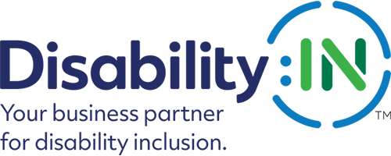

Accessibility Assessment Resources & Tools

ADA Standards: Among other things, the Americans with Disabilities Act (ADA) ensures access to the built environment for people with disabilities. The ADA Standards establish design requirements for the construction and alteration of facilities subject to the law. These enforceable standards apply to places of public accommodation, commercial facilities, and state and local government facilities. Resource Link

Guide to the ADA Standards: This guide explains requirements in the current editions of the ADA Standards issued by the Department of Justice (DOJ) and the Department of Transportation (DOT). It was developed by the U.S. Access Board in cooperation with DOJ and DOT. It is important to use this guide along with a complete copy of the ADA Standards as it explains, but does not contain or reprint, the text of the ADA Standards. Resource Link

ADA Checklist: This checklist was produced by the New England ADA Center, a project of the Human Centered Design and a member of the ADA National Network. Resource Link

ADA Checklist for Existing Facilities: This checklist, also produced by the New England ADA Center, has an online section-by-section approach that covers Approach & Entrance, Access to Goods & Services, Toilet Rooms, Additional Access. There are also separate Recreational Checklists. Resource Link

Creating Accessible Programming: Created by the University of Texas, this resource focused on building accessibility into the planning stages of programming. This helps eliminate barriers for participation and create an inclusive environment for people with disabilities with regards to
physical, instructional, and attitudinal barriers. Resource Link

A Guide to Planning Accessible Meetings: Originally published by Independent Living Research Utilization in 1993, this tool was updated by the Mid-Atlantic ADA Center and TransCen, Inc. in 2015. This version includes regulatory updates along with practical guidance from a host of meeting planning professionals and subject matter experts. Resource Link

Microsoft Toolkit on Creating Accessible Events: Microsoft released a toolkit to help each of us create accessible events that are delightful, welcoming, and an inclusive experience for people with and without disabilities. Resource Link

Effective Emergency Preparedness Planning: Addressing the Needs of Employees with Disabilities: A tool developed by the U.S. Department of Labor’s Office of Disability Employment Policy. Resource Link
Job Accommodation Network’s Steps for Including Employees with Disabilities in Emergency Evacuation Planning: Recommendations for including general accommodations and supports for with individuals with motor, sensory and cognitive/psychiatric disabilities. Resource Link.
National Council on Disability’s Effective Communications for People with Disabilities: Before, During and After Emergencies: Report identifies barriers, facilitators, and successful practices to providing effective emergency-related communications. Resource Link
Disability:IN’s Accessible Technology Procurement Toolkit: Review your policies and procedures that provide accessible technology experiences for your employees, clients and guests. Resource Link

