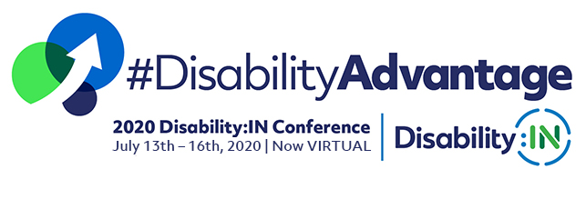

_________________________________________________________

DISABILITY:IN 2020 ANNUAL CONFERENCE & EXPO
Participant Guide
_________________________________________________________

EVENT DESCRIPTION
The Disability:IN Annual Conference is a three-day conference including cutting-edge educational sessions, enhanced networking and recruiting, and high-profile speakers. Over 2,000 attendees will connect from around the globe to virtually attend this premier event on disability inclusion in business. This year’s conference includes seven tracks including, ERG/BRG, Global, Marketplace, NextGen, Supply Chain, Technology and Workplace. The Inclusion Awards recognizing top companies, individuals, and suppliers that are leading the efforts in disability inclusion, and Disability Equality Index top scoring companies will be awarded during the evening of Wednesday, July 15 from 6:00 pm – 7:00 pm Eastern.

Disability:IN is the leading nonprofit resource for business disability inclusion worldwide. Our network of more than 220 corporations expands opportunities for people with disabilities across enterprises. Our organization and 27 Affiliates raise a collective voice of positive change for people with disabilities in business.

General Information
  - Virtual Conference Dates: July 14-16, 2020.

  - Inclusion Awards : July 15, 2020.

  - Pre-Conference Dates: July 7-13, 2020.

  - Session Time/Schedule: Visit the Virtual Conference Agenda here.
  - Attire: Casual. Business attire not required.

  - Digital Platform: ON24 is the Digital Experience Platform that will be hosting Disability:IN 2020 Virtual Conference. For an example ON24 session and to experience what the session may be like, click here: Microsoft Example

Login Information
  - Login Instructions: An email will be sent to you prior to the start of the conference with the conference landing page. When you try to access a session, you will be prompted to enter your email address as verification of your registration.
  - Pre-Registration for Specific Session: None. Attendees will be able to come and go as they please to any of the sessions!
  - Sessions at Attendee Capacity: Should the session be full, you will receive notification that you will be able to watch the session On Demand. On Demand sessions will be available approximately 24 hours after the scheduled session time.
  - Rewind: Due to the nature of the webcast, if you arrive late, you will not be able to rewind the session to view what you missed. However, attendees can go back to watch what they missed on On Demand.
Viewing Experience & Technology Needs
  - We recommend using WIFI or a wired Internet connection.
  - Webinars are bandwidth-intensive, so closing any unnecessary browser tabs will help conserve your bandwidth.
  - The webcast is being streamed through your computer, so there is no dial-in number. For the best audio quality, please make sure your computer speakers (or headset) are turned on and the volume is up so you can hear the presenters.
  - Logging off your VPN is recommended, as this can cause some networks to slow.
  - You can find additional answers to some common technical issues located in the Help Engagement Tool at the bottom of your ON24 platform screen.
Accessibility
  - All sessions will be Captioned and include ASL, so all attendees can expect to have those features included.
  - We strive to comply with the W3C’s Web Content Accessibility Guidelines (WCAG) 2.1. Specifically, we aimed to meet AA standards, and in the areas we could not, we maintained an A baseline standard.

  - At the bottom of your screen are multiple application engagement tools you can use. All the engagement tools are resizable and moveable.

  - To maximize the screen, click the square on the titlebar at the top right corner. To minimize the screen, click the bar on the titlebar at the top right corner.

Plenary Session Example
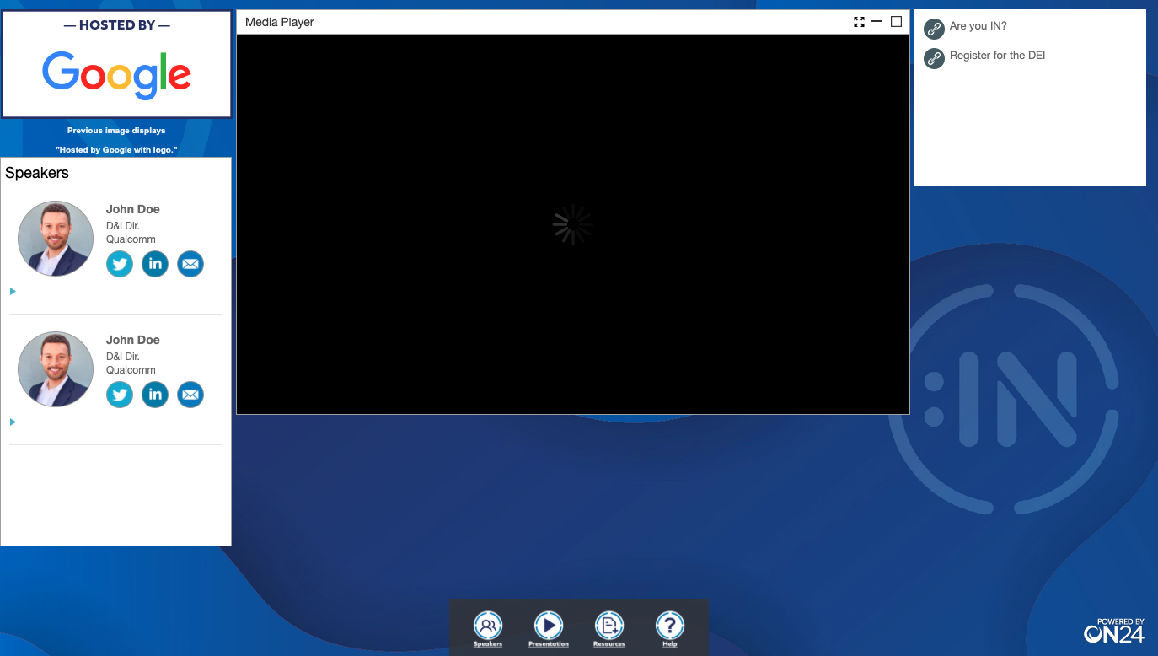
Breakout Session Example
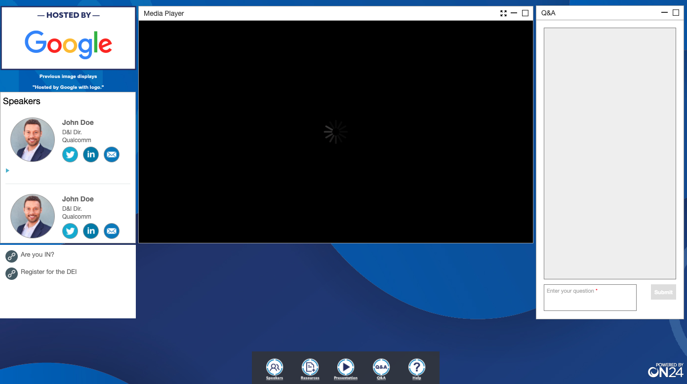

  - The Q&A window is on the rightside of the Breakout Session window.
A participant can type a question into the Q&A window during the session.
Exhibit Booth
  - The Exhibit Booth will allow for chatting with exhibit booth attendants, if they are present, as well as direct outreach via the “EMAIL US” link in the resource window or the email of the booth attendant.
  - Booth attendent will be available to chat during exhibit hours only.
  - Participant must click on the “Chat” link to load the chat window.
Exhibit Booth Example
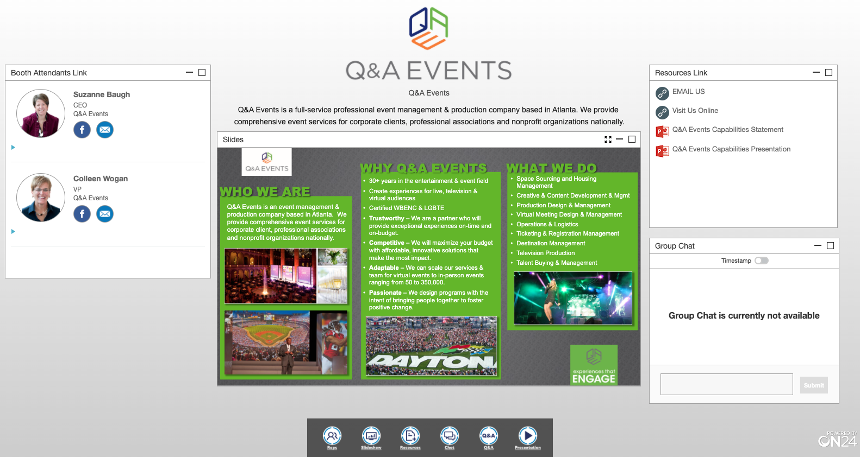

Recordings
- An On Demand version of the webcast will be available approximately 24 hours after the webcast and can be accessed using the same audience link that was sent to you earlier.

Media and Communications
- Connect with us on Social Media.
  - Facebook: https://www.facebook.com/DisabilityIN/
  - Twitter: @DisabilityIN
  - Instagram: @DisabilityIN
  - LinkedIn: https://www.linkedin.com/company/disability-in
  - Hashtags: #DisabilityAdvantage #AreYouIN

