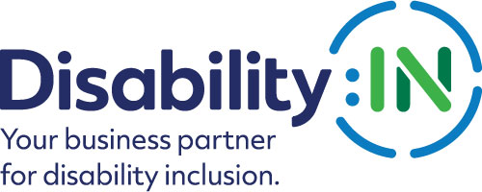
2023 Disability:IN Inclusion Awards
Accessible Product of the Year Nomination

THE DEADLINE FOR NOMINATIONS IS
FRIDAY, NOVEMBER 18, 2022

The 2023 Disability:IN Inclusion Awards Accessible Product of the Year Award recognizes a company for developing a product or service that are inclusively designed. A company must be a corporate partner of Disability:IN to be considered for this award.
Please note that if your company is selected to receive this award, you will be asked to submit photos and/or videos to Disability:IN for use in an introductory video that will be shown during the award presentation at the 2023 Disability:IN Annual Conference and Expo in Orlando, FL July 10 – 13.
These visuals will need to be submitted 4 weeks after notification. Will you be able to do this? Yes __ No__
Please complete the nomination form in its entirety:
1. Organization Name:
2. Contact information of primary company representative to be notified:
Name
Title
Organization
Mailing Address
Phone
Email
Website
3. Contact information of a secondary company representative to contact:
Name
Title
Organization
Mailing Address
Phone
Cell Phone
Email

4. Contact information of person responsible for completing the nomination form:
Name
Title
Organization
Mailing Address
Phone
Email

5. Please provide an overview of the company including founding date, type of industry, mission statement, head quarter’s city and state, whether it is national or multi-national, number of employees in the U.S. and number of employers outside the U.S. (1,000 words or less)
6. Please present a narrative that provides the background, motivation, process, innovations, and results that your company experienced in developing the accessible product or service. (narrative only; please do not attach documents) (2,000 words or less) 70 points
7. Please provide links to the advertisements, communications, products, or service descriptions cited in your narrative. (20 points)
8. Please provide any other supporting information to help the awards committee in the decision-making process. (narrative only; please do not attach documents) (1,000 words or less) 10 points

Please do not include any attachments. Please provide links in your narrative to supporting information.
PLEASE DO NOT CONVERT FORM TO PDF
Submit your electronic nomination and any questions to: awards@disabilityin.org

Award recipients will be selected by committee and will be recognized and receive their awards during the 2023 Disability:IN Annual Conference and Expo in Orlando, FL, July 10 – 13. Please note that late nominations will not be accepted.

THE DEADLINE FOR NOMINATIONS IS
FRIDAY, NOVEMBER 18, 2022

Thank you for submitting your nomination to the
2023 Disability:IN Inclusion Awards!

