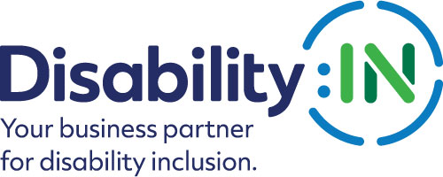

2023 Disability:IN Inclusion Awards
ERG/BRG Executive Sponsor of the Year
Award Nomination Form

THE DEADLINE FOR NOMINATIONS IS:
FRIDAY, NOVEMBER 18, 2022

The ERG/BRG Executive Sponsor of the Year Award recognizes one Executive Sponsor of their company’s disability ERG/BRG who has had a measurable impact on disability inclusion at the company and champions disability inclusion across the enterprise.

Award criteria:
- Nominee’s company must be an current active corporate partner of Disability:IN.
- The nominee must be the official executive sponsor of the company’s ERG/BRG related to disability.
- The nominee must be active in advocating for and advancing disability inclusion, continuously and current for the past calendar year.
- Nominations must come from the company’s disability ERG/BRG
- The nomination must be submitted with one (1) letter of support from a company executive.
- The winner must be prepared to accept the award that will be presented during the 2023 Disability:IN Annual Conference and Expo.

Please note that if your nominee is selected to receive this award, you will be asked to submit photos and/or videos to Disability:IN for use in an introductory video that will be shown during the award presentation at the 2023 Disability:IN Annual Conference and Expo in Orlando, Florida July 10 -13.

*These visuals will need to be submitted 4 weeks after notification.
Will you be able to do this? Yes __ No__
Please complete the nomination form in its entirety: (Limit responses to three pages)
Information on Nominee:

Nominee Name
Title
Organization
Mailing Address
Phone
Email

Contact information of person responsible for completing the nomination form:
Name
Title
Organization
Mailing Address
Phone
Email

Contact information of primary company representative to be notified if nominee is a finalist:

Name
Title
Organization
Mailing Address
Phone
Email
Website

Contact information of a secondary company representative to contact if nominee is a finalist:

Name
Title
Organization
Mailing Address
Phone
Cell Phone
Email
Please provide a brief bio (no more than one page) for the committee to review. Supporting documents are encouraged and will not count against word limits.

- Please describe how your Executive Sponsor has been a leader on disability issues within the company? (1,000 words or less) 30 points

- Please describe how your Executive Sponsor has been a leader on disability issues outside the company? (1,000 words or less) 30 points

- How has your Executive Sponsor leveraged the Disability Equality Index to advance disability inclusion and equality in the company? (1,000 words or less) 20 points

- Why is the nominee deserving of the this award? (500 words or less) 10 points

Total Points Possible = 100

PLEASE DO NOT CONVERT FORM TO PDF.
Submit your electronic nomination and any questions to: awards@disabilityin.org

The deadline for nominee submissions is 5 p.m. EST on Friday, November 18, 2022. Award recipients will be selected by committee and will be announced at the 2023 Disability:IN Annual Conference and Expo in Orlando, Florida July 10 – 13. Please note that late nominations will not be accepted.

Thank you for submitting your nomination to the
2023 Disability:IN Inclusion Awards!

