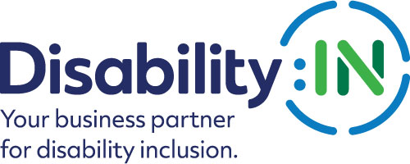
2023 Disability:IN Inclusion Awards
ERG/BRG of the Year Nomination

THE DEADLINE FOR NOMINATIONS IS
FRIDAY, NOVEMBER 18, 2022

The ERG/BRG of the Year Award recognizes the one Employee/Business Resource Group at a national, multi-national, or multi-state company with 1000 or more employees that most exemplifies programs, strategies, and initiatives that have resulted in measurable results in the area of disability inclusion in the workplace, marketplace, and supply chain.
For this category, a company must self-nominate. A company must also be a corporate partner of Disability:IN to be considered for this award. If you have received this award within the past 3 years you are not eligible to apply.
Since Disability:IN recognizes that building a disability-inclusive company is a cumulative effort done over time, the information presented should reflect this and include recognitions and awards received in previous years.
Please note that if your ERG/BRG is selected to receive this award, you will be asked to submit photos and/or videos to Disability:IN for use in an introductory video that will be shown during the award presentation at the 2023 Disability:IN Annual Conference and Expo in Orlando, Florida July 10 – 13.
These visuals will need to be submitted 4 weeks after notification. Will you be able to do this? Yes __ No__

Please complete the nomination form in its entirety:
- Company Name:
- ERG/BRG Name:
3. Contact information of primary company representative to be notified:
Name
Title
Organization
Mailing Address
Phone
Email
Website

4. Contact information of a secondary company representative to contact:
Name
Title
Organization
Mailing Address
Phone
Cell Phone
Email
5. Contact information of person responsible for completing the nomination form:
Name
Title
Organization
Mailing Address
Phone
Email
5. Please provide an overview of the company including founding date, type of industry, mission statement, head quarter’s city and state, whether it is national or multi-national, number of employees in the U.S. and number of employers outside the U.S. (500 words or less)
6. Please describe what the ERG/BRG has done to promote and support the full inclusion of people with disabilities both internally and/or externally. Please provide a specific example(s) of these initiatives and their results. Links to supporting information are encouraged. (2,000 words or less) 85 points
7. Please provide any other supporting information to help the awards committee in the decision-making process. Links to supporting information are encouraged. (1,000 words or less) 15 points

Please do not include any attachments. You may include links in your narrative to supporting information.
PLEASE DO NOT CONVERT FORM TO PDF
Submit your electronic nomination and any questions to: awards@disabilityin.org

Award recipients will be selected by committee and will be recognized and receive their awards during the 2023 Disability:IN Annual Conference and Expo in Orlando, Florida, July 10 – 13. Please note that late nominations will not be accepted.

THE DEADLINE FOR NOMINATIONS IS
FRIDAY, NOVEMBER 18, 2022

Thank you for submitting your nomination to the
2023 Disability:IN Inclusion Awards!

