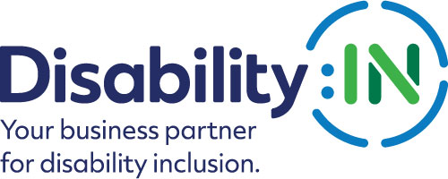

2023 Disability:IN Inclusion Awards
NextGen Leader of the Year
Award Nomination Form

THE DEADLINE FOR NOMINATIONS IS:
FRIDAY, NOVEMBER 18, 2022

The NextGen Leader of the Year Award recognizes an alumnus of the Disability:IN NextGen Leader Program who is now employed with a Disability:IN Corporate Partner and has shown outstanding leadership and commitment to disability inclusion within their company.

Award criteria:
- The nominee must be an individual from the corporate sector (not a government entity or nonprofit service provider).
- The nominee must be an alumnus of the Disability:IN NextGen Leader Program.
- The nominee must now be employed with a Disability:IN Corporate Partner.
- The nominee must be active in advocating for and advancing disability business inclusion, continuously and current for the past calendar year.
- Self-nominations are accepted, although not encouraged.
- The winner must be prepared to accept the award that will be presented during the 2023 Disability:IN Annual Conference and Expo in Orlando, Florida July 10 – 13.

Please note that if your nominee is selected to receive this award, you will be asked to submit photos and/or videos to Disability:IN for use in an introductory video that will be shown during the award presentation at the 2023 Disability:IN Annual Conference and Expo in Orlando, Florida July 10 – 13.

*These visuals will need to be submitted 4 weeks after notification. Will you be able to do this? Yes __ No__
Please complete the nomination form in its entirety: (Limit responses to three pages)
Information on Nominee:

Nominee Name
Title
Organization
Mailing Address
Phone
Email

Contact information of person responsible for completing the nomination form if other than nominee:
Name
Title
Organization
Mailing Address
Phone
Email

Contact information of primary company representative to be notified if nominee is a finalist:

Name
Title
Organization
Mailing Address
Phone
Email
Website

Contact information of a secondary company representative to contact if nominee is a finalist:

Name
Title
Organization
Mailing Address
Phone
Cell Phone
Email
Please provide a brief bio (no more than one page) for the committee to review. Supporting documents are encouraged and will not count against word limits.

- How has the nominee been engaged in advancing disability inclusion at their company? Please list specific examples of the role the nominee has played. (1,000 words or less) 40 points

- How has the nominee shown leadership in advancing disability inclusion and equality both inside and outside of the business (involvement in ERG/BRG, mentorship, accessibility initiative, etc.)? 35 points

- Please describe how Disability:IN’s programs helped get the nominee where they are today. 15 points

- Why is the nominee deserving of this award? (500 words or less) 10 points

Total Points Possible = 100

PLEASE DO NOT CONVERT FORM TO PDF.
Submit your electronic nomination and any questions to: awards@disabilityin.org

The deadline for nominee submissions is 5 p.m. EST on Friday, November 18, 2022. Award recipients will be selected by committee and will be announced at the 2023 Disability:IN Annual Conference and Expo in Orlando, Florida July 10 – 13. Please note that late nominations will not be accepted.

Thank you for submitting your nomination to the
2023 Disability:IN Inclusion Awards!

