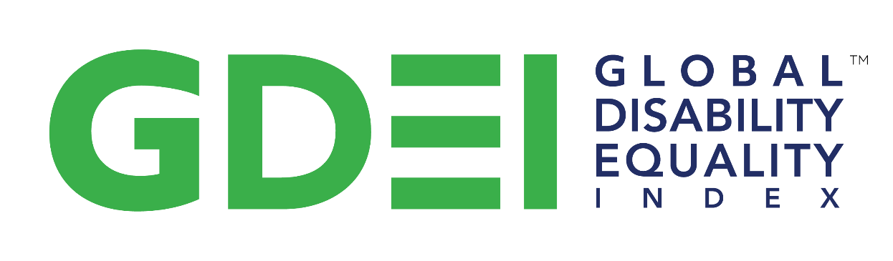

The Global Disability Equality Index (DEI) is a global benchmarking tool that helps businesses build a roadmap of measurable, tangible actions towards disability inclusion and equality.

Privacy Notice

Respecting everyone’s right to the protection of their personal data is a priority for us. As we will be processing personal data for the Global Disability Equality Index (DEI), we want to provide you with the information you need to have a clear view on the different aspects of such processing.

Please only submit someone else’s personal data if they have previously been provided with this Privacy Policy and insofar as applicable privacy and data protection legislation allows you to do so for the purposes described herein.

- Identity and contact details

The entity that processes personal data as controller for the purposes described herein is Disability:IN®, a non-profit organization based in 3000 Potomac Avenue, Alexandria, VA 22305 (United States of America) (“Disability:IN”, “we” or “us”).

You can contact us by sending a letter to the abovementioned address, or by email at PrivacyGDEI@disabilityIN.org.

- How and why we use personal data

We process the professional contact information of our contact persons at the companies that participate in the Global DEI.

Furthermore, we process the professional contact information of individuals who are responsible for global diversity management, who are champions or sponsors of an Employee Resource Group (ERG) or Business Diversity Resource Group (BRG), or who are in any other way involved in enhancing disability inclusion and equality at the participating companies.

We see it as our legitimate interest to process such information as it allows us to create and manage our global benchmarking tool that helps businesses build a roadmap of measurable, tangible actions towards disability inclusion and equality.

Please do not provide information related to someone’s health without their explicit consent.

- Internal and external recipients

In order to determine which individuals at Disability:IN will have access to personal data, the need-to-know principle will be applied. In particular, the personal data collected via the Global DEI will only be processed by the members of the team that is responsible for its management and successful completion.

The Global DEI is hosted by New Editions Consulting, Inc.

As both Disability:IN and New Editions Consulting, Inc. are located in the United States of America, all personal data that are provided in the context of the Global DEI will necessarily be processed in the United States of America.

- Data storage

Personal data will not be stored longer than required for the purpose for which they were collected.

For the avoidance of doubt, business contact information will be removed if it is no longer accurate, e.g., if the contact person in question has left the company.

- Data protection-related rights

In line with and subject to the conditions set forth in the applicable data protection legislation, anyone whose personal data are processed by us as described herein has the right to request us access to and rectification or erasure of their personal data or restriction of processing concerning themselves, or to object to processing or, if applicable, to withdraw their consent, as well as the right to data portability.

To exercise these rights or to obtain further information, please contact us as indicated in section 1 above.

If you believe that your rights have been infringed as a result of the processing of your personal data, you can lodge a complaint with a supervisory authority.

